Hunting ELK Playground (Lab 3)

LAB 16.3

Scenario
This lab features an ELK-based SIEM loaded with events related to numerous attacker TTPs (https://github.com/thomaspatzke/elk-detection-lab). Use it as a detection playground to practice your ELK-query-writing skills.

Goals
The learning objective of this lab is the rule generation ability.

What you will learn
You will learn how to utilize available logs to detect malicious activity on a windows

Recommended tools
- ELK
Access Kibana will be available at http://demo.ine.local:5601

Tasks

Task 1. Perform a hunt for account discovery
Search for technical articles and posts on Account discovery, which is used by adversaries to get a listing of local system and domain accounts. Then define an ELK query which detects this kind of activity.
Additionally, in your final query for this task, filter for "winlog.computer_name: MSEDGEWIN10".
Hints:
- https://attack.mitre.org/techniques/T1087/
- https://gallery.logrhythm.com/independent-white-papers/uws-whats-new-in-the-windows-10-security-log-independent-white-paper.pdf

Task 2. Hunt for Persistence through Accessibility Features
Research for technical articles and posts on abuse of accessibility features. Then define an ELK query which detects this kind of activity. For this hunt, we will use Sysmon Event ID 1.
Use T1015 as a starting point.
Additionally, in your final query for this task, filter for "winlog.computer_name: DC1.insecurebank.local".
Hints:
- Persistence through file replacement with cmd.exe
- Persistence as the SYSTEM user

Task 3. Hunt for Privilege Escalation through Scheduled tasks
Research for technical articles and posts on abuse of Scheduled tasks. Then define an ELK query which detects this kind of activity. For this hunt, we will use only Sysmon Events. Note that the environment contains of Windows 7 workstations.
Use T1053 as a starting point.
Hints:
- https://www.threathunting.se/2019/10/29/dont-trust-your-windows-task-scheduler/

Task 4. Hunt for RDP over a Reverse SSH Tunnel
Research for technical articles and posts on RDP over Reverse SSH tunnel. Then define an ELK query which detects this kind of activity.
Filter results for "winlog.computer_name: PC01.example.corp".
Hint:
- https://blog.menasec.net/2019/02/threat-hunting-25-rdp-over-reverse-ssh.html

SOLUTIONS
Below, you can find solutions for each task. Remember though, that you can follow your own strategy, which may be different from the one explained in the following lab.
Start firefox browser and access Kibana at http://demo.ine.local:5601
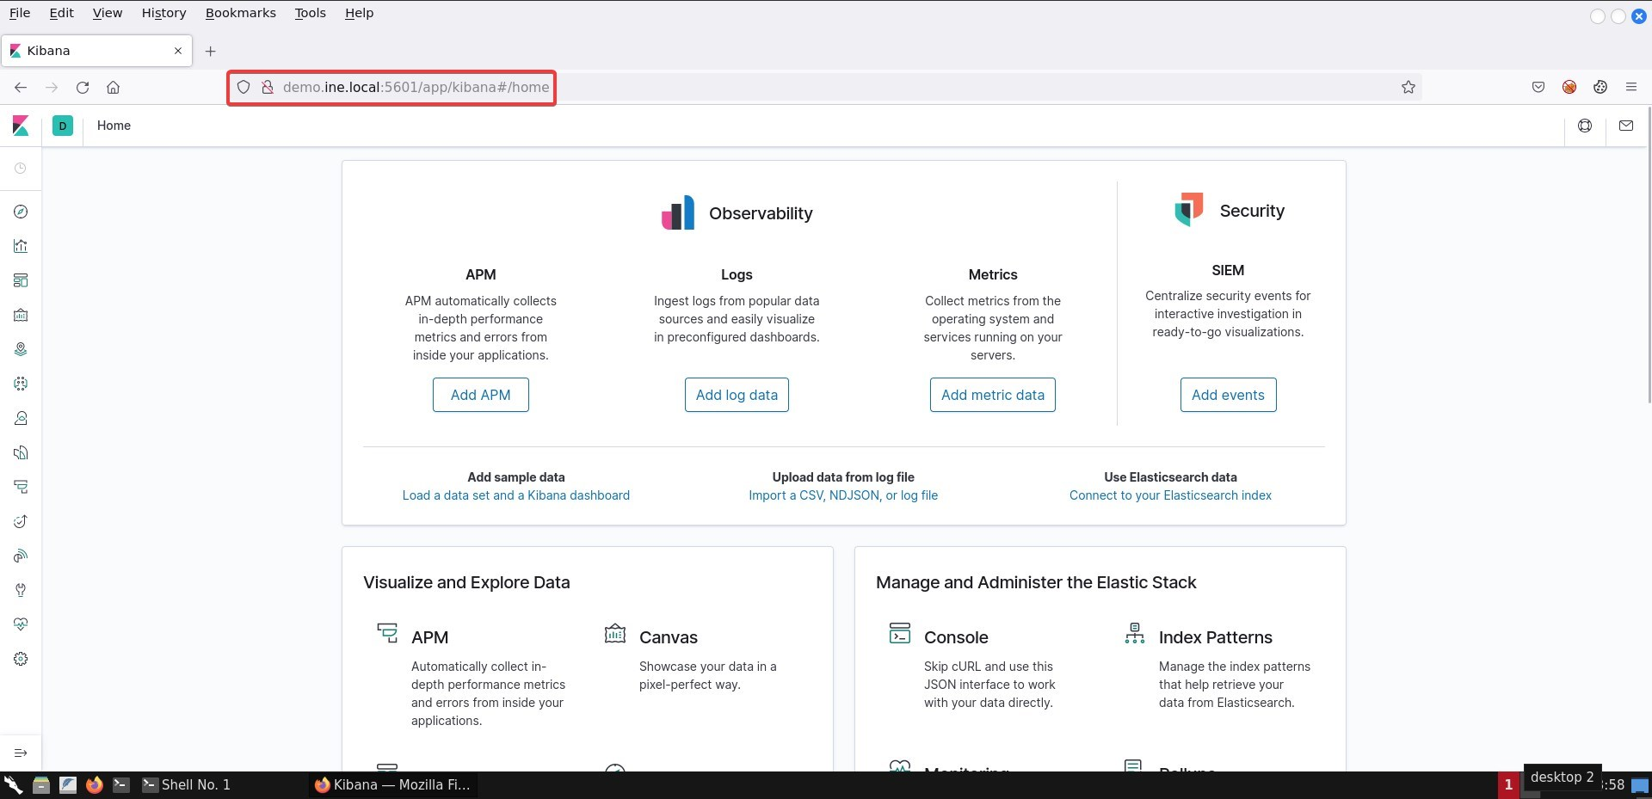
Go to Discover
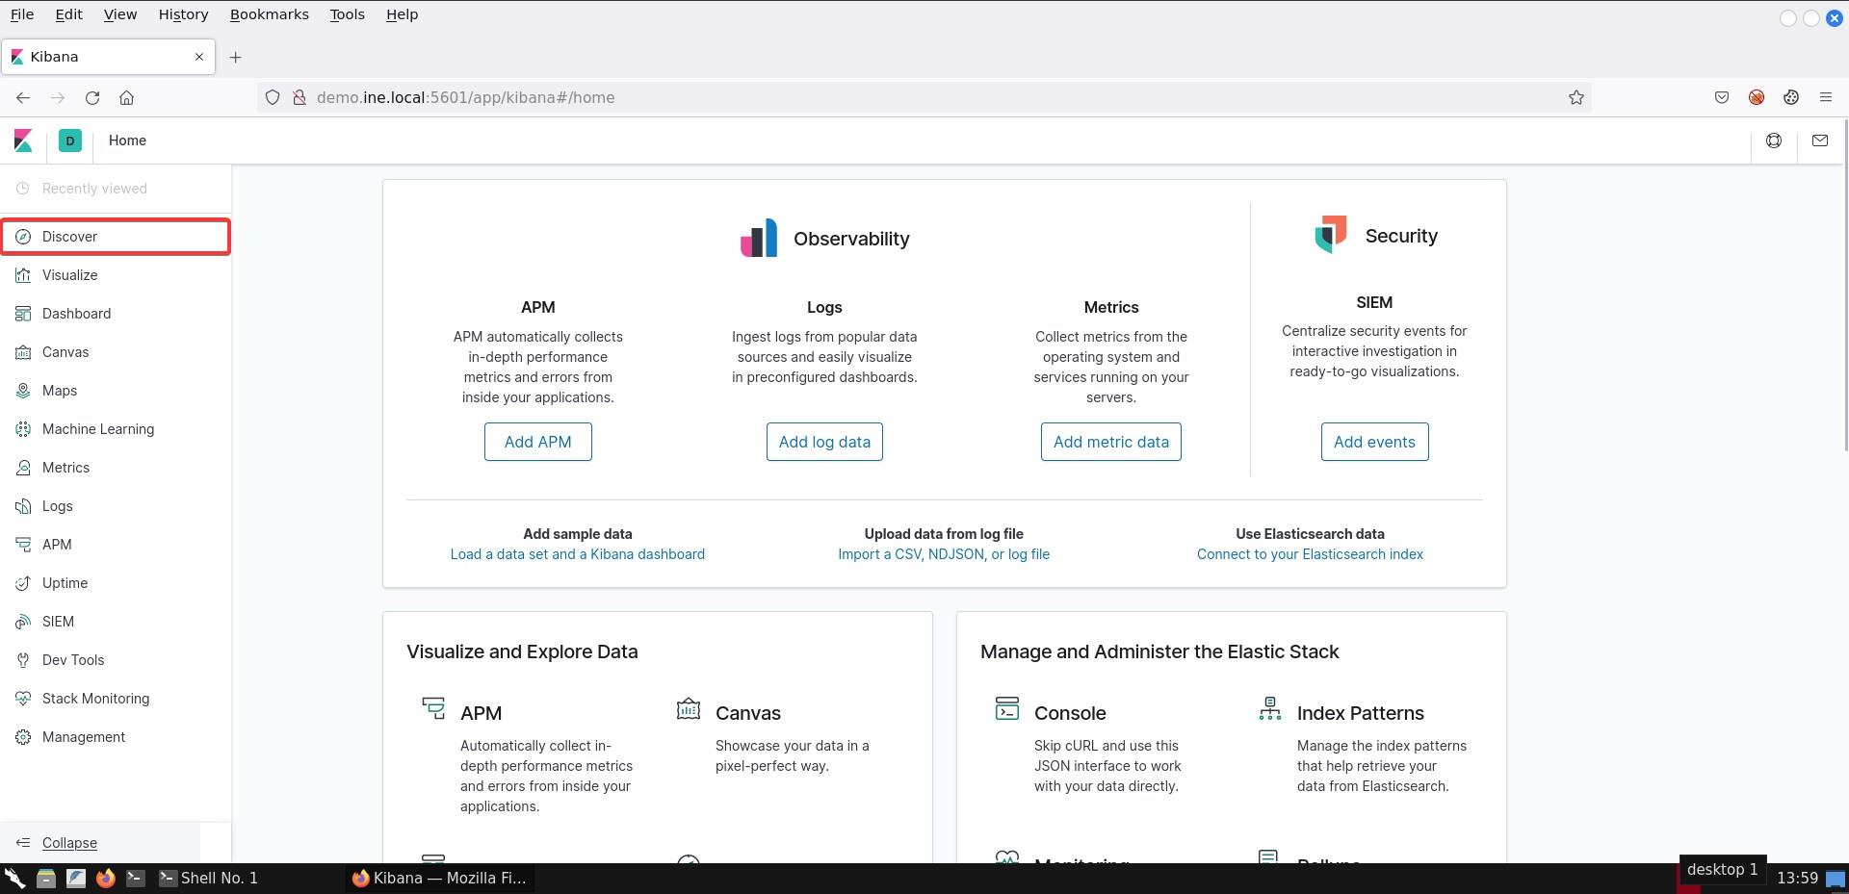
Select winlogbeat-* and select start date from November-1-2017 to till date.
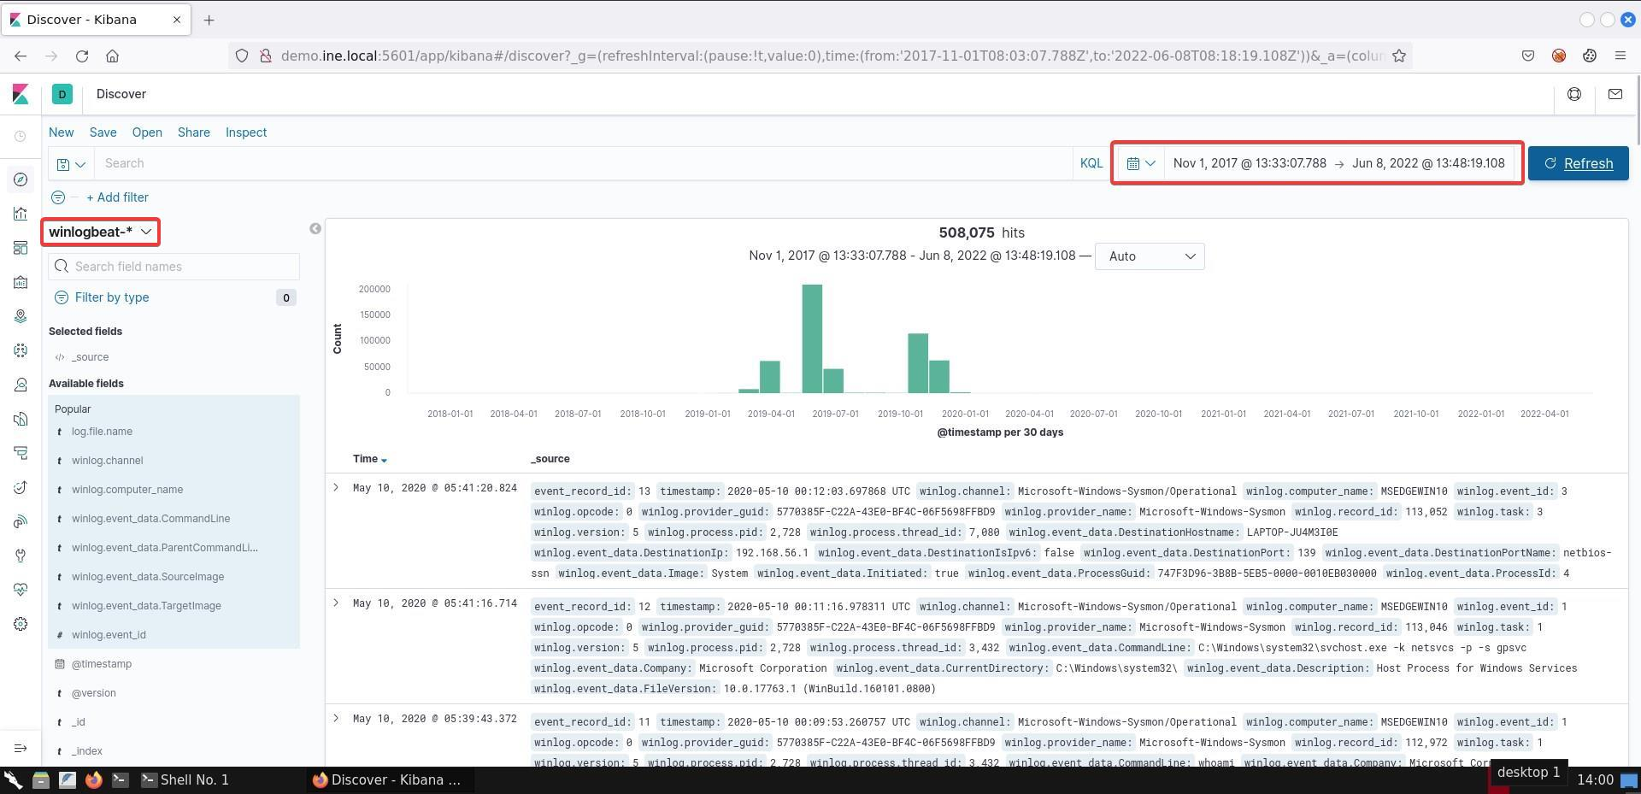

Task 1. Perform a hunt for account discovery
In this task, we begin by reading the documentation in the hint's area. After going through it, we'll discover that "net" is a utility often used for this enumeration. Moreover, Windows 10 has introduced two new events, which are quite interesting:
- 4798 -- A user's local group membership was enumerated
- 4799 -- A security-enabled local group membership was enumerated
Taking the above into account, we create the following query:
winlog.event_id:(4798 OR 4799) AND winlog.event_data.CallerProcessName:(net OR net1) AND winlog.computer_name: MSEDGEWIN10
Once we execute the query, we get the following output (for brevity, only display user who did the action and the user/group name that was being enumerated):
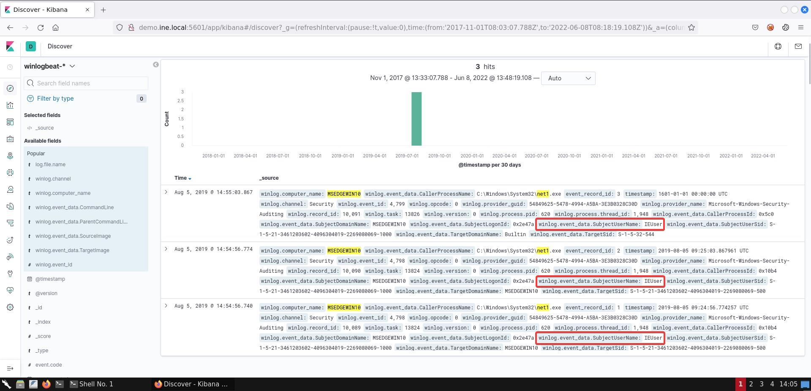
The user IEUser has been enumerating the built-in group Administrators, and the built-in account Administrator.

Task 2. Hunt for Persistence through Accessibility Features
Reviewing the information available in T1015, we assemble the following list of targeted executables:
- Sethc.exe
- Utilman.exe
- Osk.exe
- Magnify.exe
- Narrator.exe
- DisplaySwitch.exe
- AtBroker.exe
Now, taking into account that the hint refers to file replacement with cmd.exe, what we would be interested into, is if a file with any of the names listed above contains the Description field that matches cmd.exe -- essentially, we are looking for renamed cmd.exe. Finally, the user it would execute as is "NT AUTHORITY/SYSTEM". The query we construct is as follows:
winlog.event_data.Image:("C:\Windows\System32\osk.exe" OR "C:\Windows\System32\sethc.exe" OR "C:\Windows\System32\utilman.exe" OR "C:\Windows\System32\magnify.exe" OR "C:\Windows\System32\narrator.exe" OR "C:\Windows\System32\displayswitch.exe" OR "C:\Windows\System32\atbroker.exe") AND winlog.event_data.Description:"Windows Command Processor" AND winlog.event_data.User:"NT AUTHORITY\SYSTEM" AND winlog.computer_name:DC1.insecurebank.local
Once the query is executed, we get the following match:
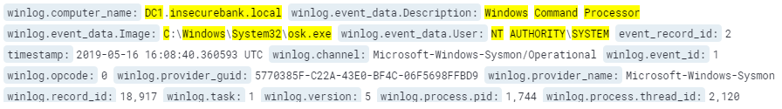

Task 3. Hunt for Privilege Escalation through Scheduled tasks
Reading through the hinted document, we create a list of writable locations by all users, which is suspicious to run tasks from (remember to filter out known-good!). These locations are:
- C:\users\*
- C:\programdata\*
- C:\Windows\Temp\*
Now for this hunt, we have only Sysmon logs available, therefore for our detection capability will focus on Event ID 1 (Process creation) specifically looking for execution of schtasks.exe with a command line parameter that points to one of the locations listed above.
Armed with this knowledge, we create the following query:
winlog.event_id:1 AND winlog.event_data.Image:"C:\Windows\system32\schtasks.exe" AND winlog.event_data.CommandLine:("C:\users" OR "C:\programdata" OR "C:\Windows\Temp")
Running the query, we get the following match:
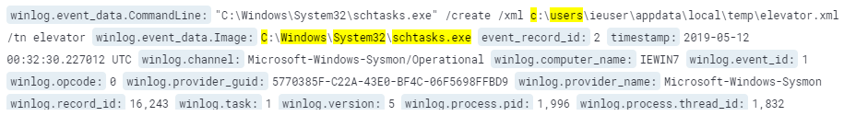
Based on the parameters passed to schtasks.exe, a new task is created. Following that activity, we can leverage Sysmon Event ID 11 (File create) to identify the creation, by querying for:
winlog.event_data.TargetFilename:"C:\Windows\System32\Tasks\elevator"
Running the query, we get the following match as we would expect:
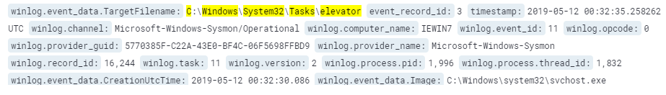
Now that the task was created, we can identify if it was executed by modifying our first query but this time, we are looking at the command line argument that contains the task name "elevator" and the string "run" (which indicates task execution). We create the following query:
winlog.event_id:1 AND winlog.event_data.Image:"C:\Windows\system32\schtasks.exe" AND winlog.event_data.CommandLine:("run" AND "elevator")
Running the query, we get the following match:
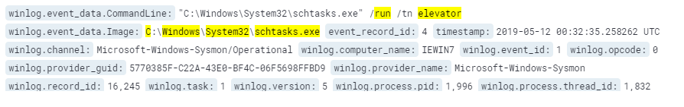
Indeed the task was executed. If we follow the documentation provided on the blog post hinted by the task, we would be interested to see if the task has spawned any of the following as the SYSTEM user:
- wscript.exe
- rundll32.exe
- cscript.exe
- regsvr32.exe
- cmd.exe
- wmic.exe
- mshta.exe
- powershell.exe
Taking into consideration that the environment is based on Windows 7 workstations and as stated by T1053, "taskeng.exe" will be the executing process starting one of those listed above. Taking this into consideration, we construct the following query:
winlog.event_id:1 AND winlog.event_data.ParentImage:"taskeng.exe" AND winlog.event_data.Image:("cmd.exe" OR "wscript.exe" OR "rundll32.exe" OR "cscript.exe" OR "regsrv32.exe" OR "wmic.exe" OR "mshta.exe" OR "powershell.exe")
When executed, we get the following output:
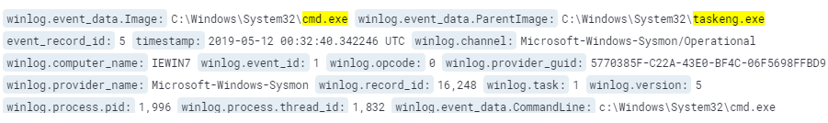
Command prompt was started several milliseconds after the scheduled task was executed. If we expand the fields, we will also note that it was executed as "NT AUTHORITY\SYSTEM".
Finally, we can search for traces of task deletion in a similar fashion as we searched whether it was executed, however, now we will look for "delete" instead of "run". Our query is:
winlog.event_id:1 AND winlog.event_data.Image:"C:\Windows\system32\schtasks.exe" AND winlog.event_data.CommandLine:("delete" AND "elevator")
When we execute the query, we get the following output:
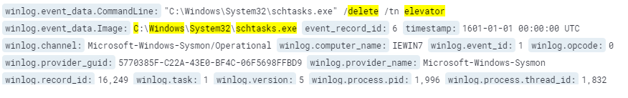

Task 4. Hunt for RDP over a Reverse SSH Tunnel
By reviewing the hinted post, to discover this activity, we should be looking at Event ID 4624 (Successful logon) with Logon type 10 (indicating RDP). Moreover, we should ensure that the network source address points to the loop IP address (127.0.0.1). Converting this into ELK query, and taking into account the computer name given in the task, we get the following:
winlog.event_id:4624 AND winlog.event_data.LogonType:10 AND winlog.event_data.IpAddress:"127.0.0.1" AND winlog.computer_name:"PC01.example.corp"
When executed, we get the following output:
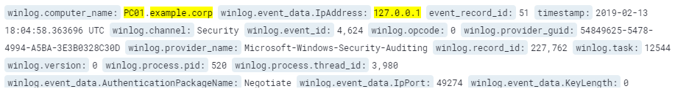
Here we see that we have a match and have therefore successfully identified the activity our hunt is focused on.

KEY TAKEWAYS
- There are numerous ways for an adversary to achieve their goal. Being familiar with as many as possible attacks can aid hunters in creating better detection rules performing successful hunts.
- Hunting playgrounds are a great source of different attacks, helping hunters in increasing their abilities.

